

Placement Empowerment Program

Cloud Computing and DevOps Centre

**Set Up a Cloud-Based Monitoring**

Service Enable basic cloud monitoring (e.g., CloudWatch on AWS). View metrics like CPU usage and disk I/O for your cloud VM.

Name: Manashaa U Department: CSE

Introduction:

In this Proof of Concept (POC), I have give step by step explanation about viewing information and creating alerts

Step-by-Step Overview Step

Open the azure portal

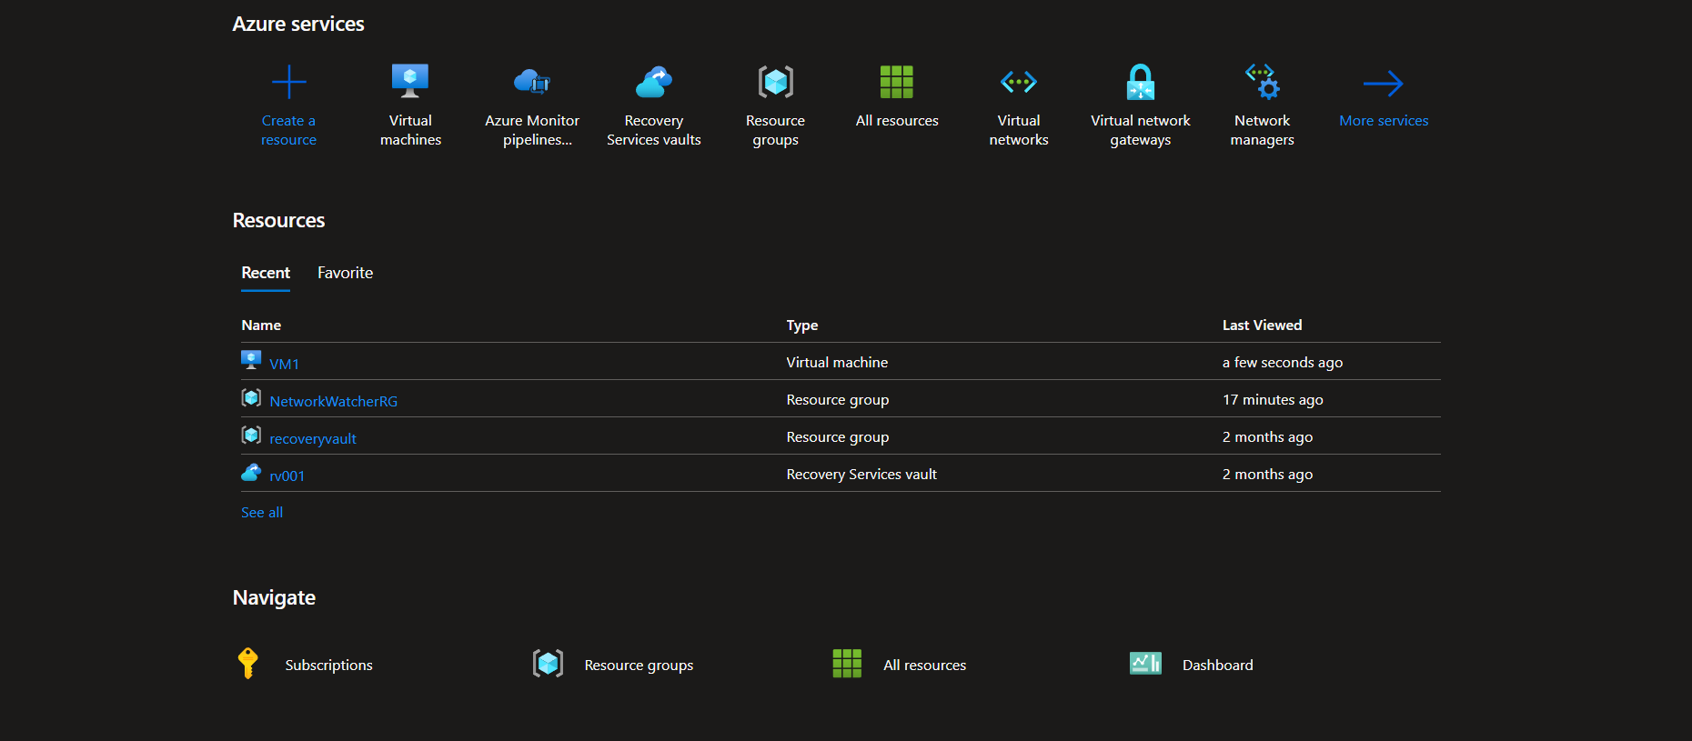

2.search for “monitor”

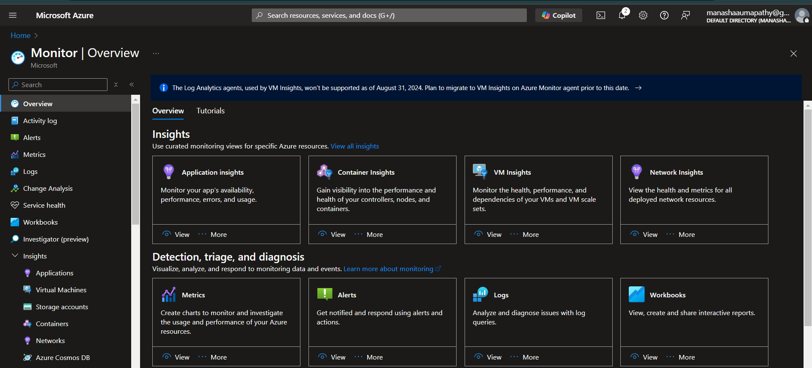

3) click on insights hub and see the information

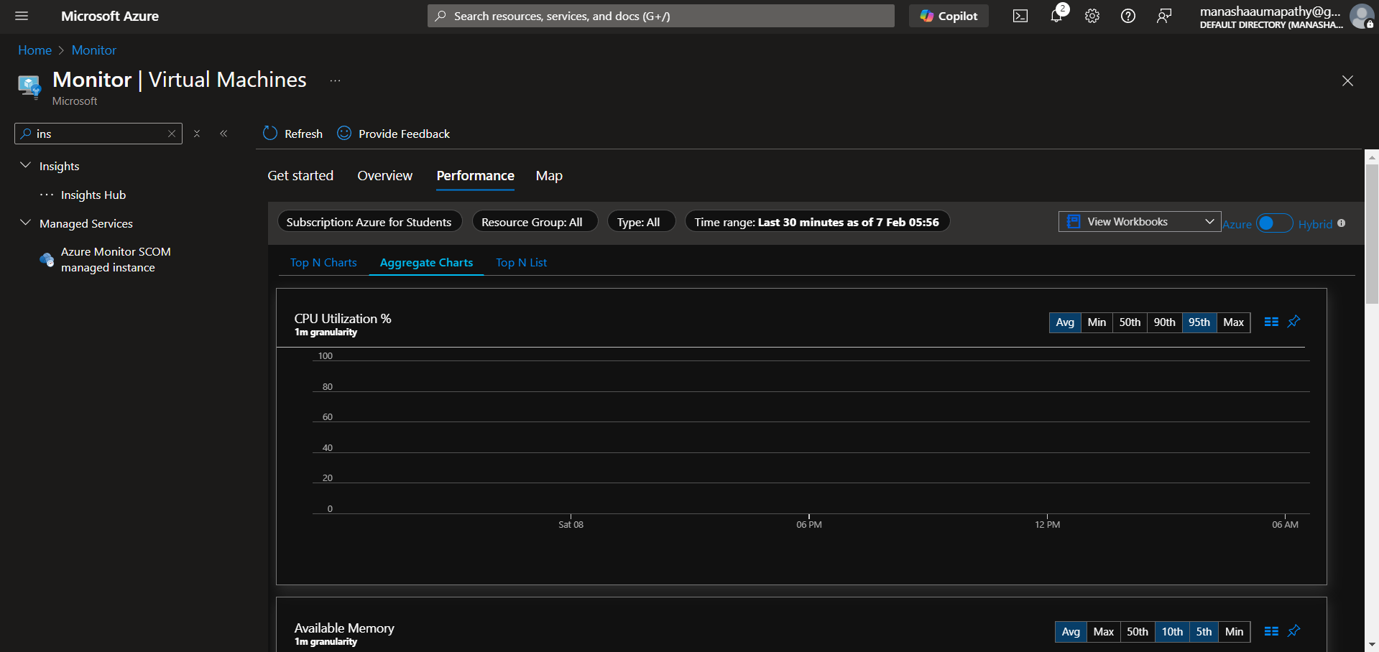

4)you can also create an alert by searching for “alert” and creating a new one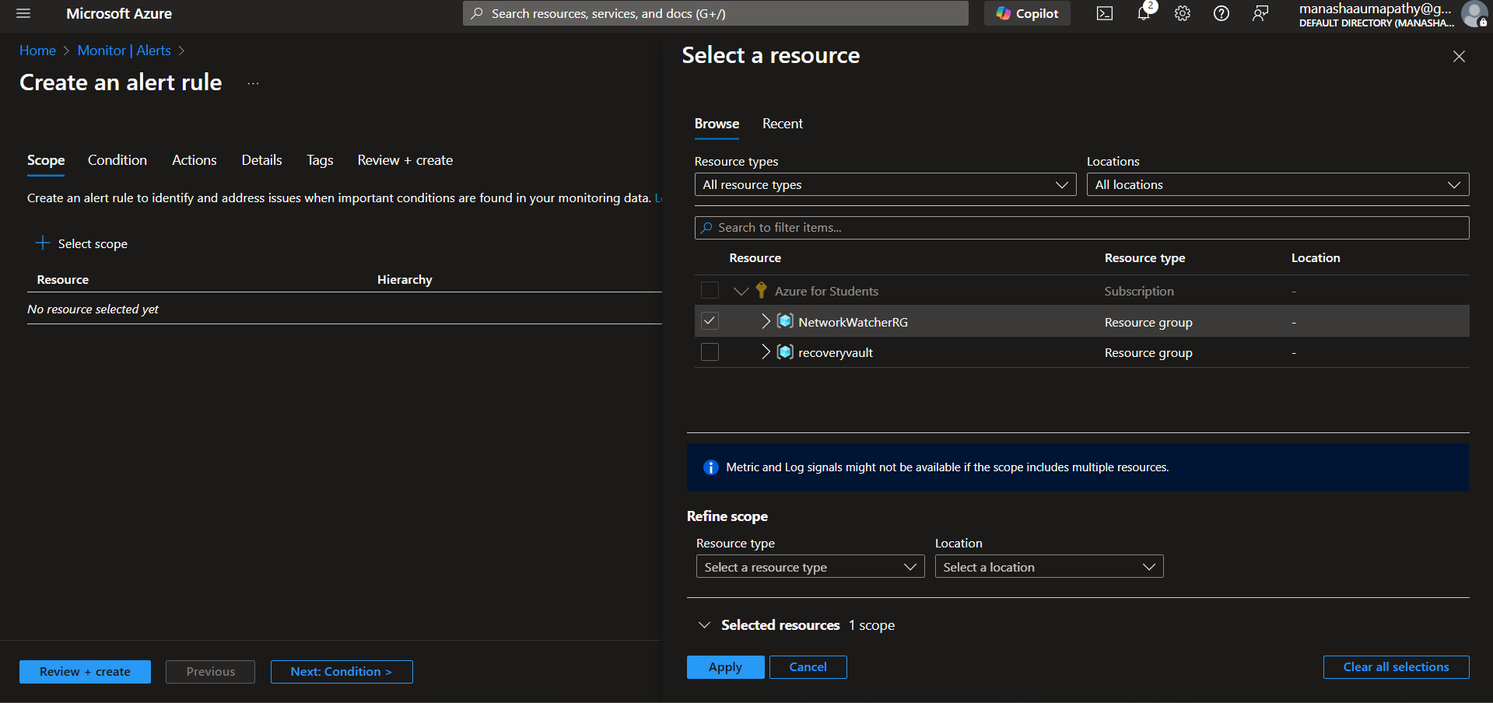

Outcome:

Azure Monitor collects and analyzes performance metrics from Azure resources for a unified monitoring experience. It includes Log Analytics for log data analysis and Application Insights for performance monitoring. With Azure Monitor, users can set up alerts, customize dashboards, and visualize data.